Project Planning Phase

# Project Planning Template (Product Backlog, Sprint Planning, Stories, Story points)

|  |  |
| --- | --- |
| Team ID | PNT2022TMID03551 |
| Project Name | Project - Real-Time Communication System Powered by AI for Specially Abled |

**Product Backlog, Sprint Schedule, and Estimation (4 Marks)**

|  |  |  |  |  |  |  |
| --- | --- | --- | --- | --- | --- | --- |
| **Sprint** | **Functional**  **Requirement (Epic)** | **User Story**  **Number** | **User Story / Task** | **Story Points** | **Priority** | **Team**  **Members** |
| Sprint-1 | Data collection | USN-1 | Collection of required data, login information from user | 2 | Low | MOHAMED NASSAAR |
| Sprint-1 |  | USN-2 | Image pre-processing | 3 | High | MOHAMED ANAS |
| Sprint-2 | Model building | USN-3 | Import the required libraries, add the necessary layers, and compile the model | 2 | Low | KARTHICK |
| Sprint-2 |  | USN-4 | Training the image classification model using  CNN | 3 | High | DEVA |
| Sprint-3 | Training and testing | USN-5 | Training the model and testing the model’s performance | 3 | High | MOHAMED NASSAAR |
| Sprint-3 |  | USN-6 | Converting the input sign language images into  English alphabets and save model for deployment | 2 | Low | MOHAMED ANAS |
| Sprint-4 | Implementation and dashboard | USN-7 | As a user, I can acknowledge the output of the system by ensuring messages are displayed. | 2 | Low | KARTHICK |
| Sprint-4 |  | USN-8 | As a user, I can get and give feedback about the system from its output. | 3 | High | DEVA |

**Project Tracker, Velocity & Burndown Chart: (4 Marks)**

|  |  |  |  |  |  |  |
| --- | --- | --- | --- | --- | --- | --- |
| **Sprint** | **Total Story Points** | **Duration** | **Sprint Start Date** | **Sprint End Date (Planned)** | **Story Points**  **Completed (as on**  **Planned End Date)** | **Sprint Release Date (Actual)** |
| Sprint-1 | 05 | 6 Days | 24 Oct 2022 | 29 Oct 2022 | 05 | 05 Nov 2022 |
| Sprint-2 | 05 | 6 Days | 31 Oct 2022 | 05 Nov 2022 | 05 | 08 Nov 2022 |
| Sprint-3 | 05 | 6 Days | 07 Nov 2022 | 14 Nov 2022 | 05 | 12 Nov 2022 |
| Sprint-4 | 05 | 6 Days | 14 Nov 2022 | 19 Nov 2022 | 05 | 19 Nov 2022 |
|  |  |  |  |  |  |  |
|  |  |  |  |  |  |  |
|  |  |  |  |  |  |  |
|  |  |  |  |  |  |  |

**Velocity:**

Imagine we have a 10-day sprint duration, and the velocity of the team is 20 (points per sprint). Let’s calculate the team’s average velocity (AV) per iteration unit (story points per day)

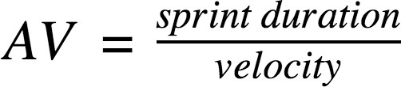

**AV = 5/10 = 0.5**

Burndown and velocity chart in jira insights :

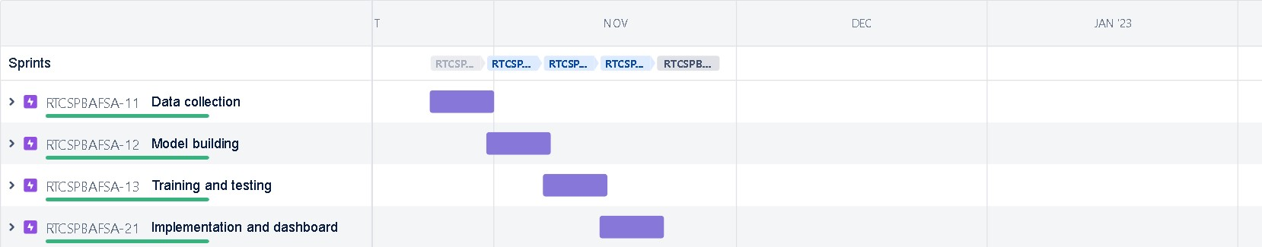

Burndown chart:

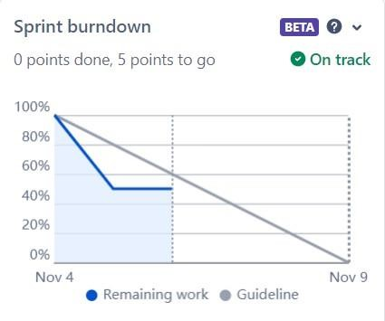

Velocity chart:

